Please fill in this form and take it to your Learning Disability Annual Health Check. You can ask your carer to help.
Do you smoke or vape? | Please circle your answer  Yes No | If you said yes, write the number of cigarettes you smoke a day. Or number of times you vape
Do you drink alcohol? | Please circle your answer  Yes No | If you drink alcohol write down what you drink. How much do you drink a week?
Do you eat healthy foods? | Please circle your answer  Yes No | Write down what foods you like to eat
Do you exercise? | Please circle your answer  Yes No | Write down what exercise you do.  How often do you exercise?
Do you take drugs?  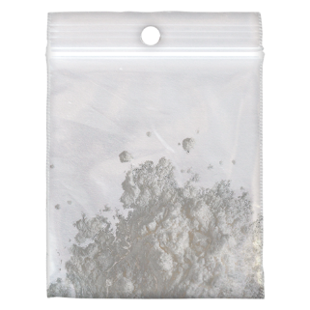 | Please circle your answer  Yes No | If you said yes, write what drugs you take. How often do you take drugs?
Do you have carers? | Please circle your answer  Yes No | Carers name………………………………………..  Carers telephone number……………………..
Do you get help from health or social care workers? | Please circle your answer  Yes No | If yes, then please give their details:  Name………………………………………………………  Job title…………………………………………………..  Name……………………………………………………..  Job title…………………………………………………..
Do you work? | Please circle your answer  Yes No | If you work, what job do you have?
How I spend my time | Please circle your answer  Am I busy?  Yes No | Write down what activities you do, for example day services, work and hobbies
Reasonable adjustments | Please circle your answer  Do you need reasonable adjustments?  Yes No | Write down what reasonable adjustments you need when going to health services
Movement  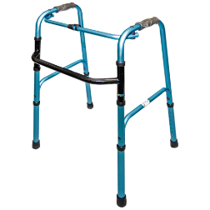  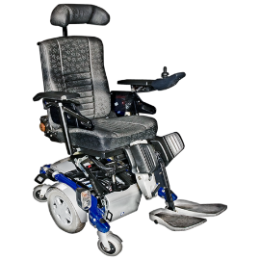 | Please circle your answer  Do you walk?  Yes No  Do you use a walking aid?  Yes No  Do you use a wheelchair?  Yes No  Do you fall?  Yes No | Please write extra information here
Daily Living | Please circle your answer  Do you need help with everyday tasks?  Yes No | Write down what help you need and  who helps you?
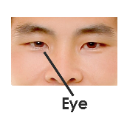  Eye test | 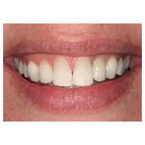  Dental check | Podiatry | 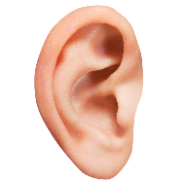  Hearing test | Screening:  Breast Smear test, Bowel | Other appointments

Do you have anything else you want to talk to the Doctor or Nurse about? Write them down inside this box

Write the date of your last appointments in the white box above

