Wigan CAMRA Branch Meeting

Tuesday, 16 April 2024 at 7pm

Real Crafty, 9 Upper Dicconson Street, Wigan, WN1 2AD

Agenda

- Chair’s opening remarks

Apologies

Minutes from the last meeting

Chair’s report

Treasurer’s report

Membership report

Cider report

LocAle report

Magazine Editor’s report

Social Secretary’s report

Pubs report

Clubs report

BLO reports

Pubs to be featured on Social Media

Any other business (AOB)

Date and time of next meetings/events
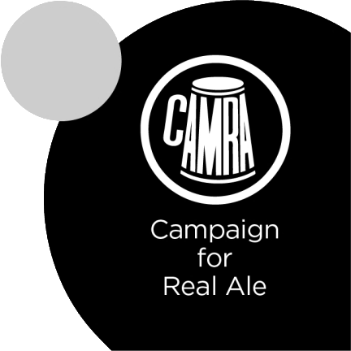
Branch meetings 2023
Wed 10 Jan 7:30pm start | Real Crafty | Branch Meeting & AGM
Wed 7 Feb 7:30pm start | Sherrington’s | Good Beer Guide 2025 voting  Nominations for Spring POTS
Thu 14 Mar @ 8pm | Standish Unity Club | Voting for Spring POTS
Tue 16 Apr 7:00pm start | Real Crafty
May |  | Nominations for Summer POTS
June |  | Voting for Summer POTS
July
August |  | Nominations for Autumn POTS
September |  | Voting for Autumn POTS
October
November |  | Nominations for Winter POTS
December |  | Voting for Winter POTS

Branch awards 2024
Pub of the Year 2024 | Wigan Central
Club of the Year 2024 | Standish Unity Club
Cider & Perry Pub of the Year | Real Crafty
Community Pub of the Year | Albion Ale House, Standish
Best New Cask Outlet | Not awarded

Pub of the Season
 | Nominated | Winner
Spring 2023 | The Raven, Wigan  Wigan Central, Wigan  Sherrington’s, Wigan | The Raven, Wigan
Summer 2023 | Delph Tavern, Tontine, Orrell  State of Kind Brewery Tap  Wigan Central, Wigan  The Anvil, Wigan | State of Kind Brewery Tap
Autumn 2023 | Albion Ale House, Standish  Delph Tavern, Tontine, Orrell  Wigan Central, Wigan | Wigan Central, Wigan
Winter 2023 | Albion Ale House, Standish  Delph Tavern, Tontine, Orrell  Sherrington’s, Wigan | Sherrington’s, Wigan
Spring 2024 | The Hingemakers Arms, Ashton  The Albion Ale House, Standish  The Delph Tavern, Tontine  The Eddington Arms, Hindley | The Delph Tavern, Tontine

