Community Action Research Programme

Camden Borough Partnership is committed to hearing and acting upon the voice of the local community. We are also committed to ensuring there is equitable access for all of the diverse Camden Borough Partnership population. We recognise that certain communities face specific barriers to accessing traditional health services and will often seek support through their local community first. It’s imperative that we are able to work with local communities and VCSE to listen to local communities around their life experiences, what matters to them in terms of living ‘well’ and their experience of accessing care and services. We are committed to ensuring these experiences must shape how we develop services, programmes and undertake strategic planning both within Camden and within North Central London programmes.

A crucial part of working with our local communities are the relationships that have been built with the community and voluntary sector. We would, like to continue to strengthen these relationships for the year ahead and build on existing networks.

We recognise the skills and strengths which exist in local communities and through the grass roots organisations they work with. Often these strengths and connections provide invaluable support where statutory services, for whatever reason, have not been able to reach or support local people and communities. Alongside this, VCSE and the support they offer can be the most effective at providing preventative and proactive support for local communities – which when properly resourced can mean local communities are less likely to fall into poor health or even crisis.
We wish to build on these skills and ensure that we contribute to investing in and building knowledge of the health and care service within our local communities and grass roots VCSE.

Camden Borough Partnership would like to undertake open conversations with local communities, as well as some conversations around key priority areas. While undertaking the community research we wish to undertake an action research approach so that we work with local people to address some of the issues they raise.

We propose to work with a partnership of VCSE organisations, with a lead facilitating organisation and a group of grass roots VCSE.

We will work the partnership to develop a research programme that is relevant to the local communities and can enable us to develop our Place-Based partnerships, to ensure priorities and the future of the partnership is grounded in and delivering what communities identify that they need to improve their health and wellbeing.

We will also provide training and support the development of peer training to the VCSE partnership on the local health and social care system. The training will focus on how to support the communities you work with to both access services and look after their own health and wellbeing.

Project overview
Camden Borough Partnership would like to undertake community action research around priority areas to support open conversations with local communities to identify and explore key inequalities around reach, access, outcomes and experiences.

We are looking to work with a lead facilitating VCSE organisation and a group of grassroots organisations – working as a joint VCSE Partnership - that are best placed to support the research ambition around the defined priority areas (see below).

Aims and objectives:
- To build a flexible, strong, and equitable VCSE partnership, bringing together a lead facilitating VCSE organisation and grass roots organisations, with equitable sharing of funding and utilising of unique skills of each organisation to work with local Camden communities;
- To develop a simple training programme (i.e. workshop with some additional peer training / mentoring) to upskill the partnership’s knowledge on Camden health and care system and services;
- For the partnership to conduct action and community research, which includes, to:
  - collaborate with and amplify the voice of local communities who experience high inequalities (in reach, access, outcomes or experiences) to identify unmet wellbeing needs;
  - meet communities where they are, so they can raise issues which matter to them and set outcomes which are meaningful for their lives;
  - address identified issues as they arise – co-designing solutions with local communities and people; bringing the services and support they need to them (working collaboratively, in conjunction with Camden Borough Partnership, with existing programmes of work)
  - raise knowledge of local health & care services across VCSE organizations and local communities;
  - act upon the feedback and views of Camden communities to ensure services are planned and commissioned with local people – and to meet their needs in terms of reach, access, outcomes and reach.

The key objectives we are looking to be achieved as part of the work are:
- To better understand people’s experiences of, so that we can listen to and develop ideas on how to improve, local solutions, services and partnerships across the statutory and voluntary health, care and housing system with local people and communities. This work will directly inform Camden Borough Partnership development;
- To engage and collaborate with local communities;
- To harness local VCSE and communities’ strength;
- To provide support to local communities and individuals to access the information and advice that’s useful for them in the way they want it, and to explore with local communities how best we could support and encourage people to manage their health and well-being.

Please note that the successful organisations can work with the Camden Borough Partnership and, where appropriate, invite statutory partners’ staff to listen directly to local people and communities.

Community research:
This brief is focused on open conversations alongside key thematic areas, and we expect the partnership to reflect these themes and come together in a way that ensures appropriate expertise and access to the impacted community groups with the resources to support people within communities:
- We are keen to explore with local people what matters to them in their local neighbourhoods (see appendix), what does health and wellbeing mean for their lives and what are the ways they envisage for themselves, their families and communities creating lives which encompass ‘start well, live well and age well.’
- This research will help shape our neighbourhood programme going forward with a focus on co-creation and listening to local residents. The research will feed in to the Camden Local Care Partnership Board and support the neighbourhood group to coproduce activities with residents.
- We also expect the lead facilitator to work with organisations who represent the diversity and ethnicity of the communities we want to hear from
- For year one of the research we want to explore some communities and areas identified through the Camden Borough partnership alongside open community conversations and questions which give people space to talk about health and wellbeing in the context of their lives.
- As part of this there are some specific areas we would like to drill down to in more detail. These are:

Target Communities:
- Known areas of deprivation, where current gaps exist, where communities struggle to be heard, where barriers exist, namely
    - West neighbourhood
      - Kingsgate House development in Kilburn (West neighbourhood)
    - NW5 neighbourhood
      - Prince of Wales Road development in Kentish Town (NW5 neighbourhood)
- A location know to the provider where there are high levels of social isolation and loneliness e.g. high numbers of people living alone, older populations

Please note that the successful organisations can work with the Camden Borough Partnership and where appropriate invite statutory partners’ staff to listen directly to local people and communities.

Reporting:
The lead facilitating organisation needs to support the collation of, and provide records and reporting on:

- Number of VCS organisations engaged and outcomes of engagement
- Number of people spoken to
- Demographics of people spoken to and population segments, if possible
- Patient/client experience surveys, where appropriate
- Qualitative thematic analysis
- Actionable recommendations

- Scope and extent of training delivered to VCSE organisations (in conjunction with Camden Borough Partnership)

- The ways in which communities have been supported, including but not limited to:
  - Providing communities with information on how to access health service (signposting)
  - Supporting communities to access to health (or other statutory services), where needed
  - Assisting clients with more complex needs to find the right information or to access the right service
  - Assisting communities to any type of wellbeing support
  - Any other ways how you identified and supported specific communities around inequalities in reach, access, outcomes and experiences
  - The impact of these community interventions
  - Learning that can be shared from the project – what worked and what didn’t
  - Patient/client experience surveys, where appropriate

Additional measures can include:
- Case studies
- Number of appointments they attend with clients
- Measures recommended by the lead facilitating organisation

Reporting structure
- Quarterly update meetings where we share the progress of the programme & current activity
    - A summary of programme development
    - With any emerging or consolidating themes including community interventions as well as research themes
- A final report at the end of the year that sets out the above measurements and thematic analysis.
- We will hold a discussion session/s with the VCSE partnership and Camden Borough Partnership leaders to discuss the findings of the project and ways the learning can be taken forward.
We aim to reflect on and implement findings across the year – rather than waiting for the final report – in this way we can respond to research in-time and develop a two-way conversation between the partnership and local communities and statutory partners.

We will work with you (the VCSE Partnership) to address the recommendations in the final report and work together to communicate with local communities how the findings have influenced and directly developed the Camden Borough Partnership and programmes.

Developing the partnership
We are keen the partnership can develop as a fluid model so that there can be the potential to bring in new partners for future funding opportunities.

Across the year there will usually be specific topics or service areas we will need to work with local people to develop. Our long-term aim is that the partnership may be a key vehicle to do this, with the appropriate additional funding. But we can only do this if the partnership model is flexible enough that it can evolve to bring in new VCSE.

When developing the partnership and proposal please factor this into the model you develop.

Supporting documents:

Timescale and budget

Timeframe:
Start date: 15th August 2022
End date: 30th April 2023

Budget: £40 000
The lead provider will receive the payment in full after 15th August 2022, subject to financial checks. The lead provider will need to work with the partnership to determine an equitable funding model – that ensures grass roots organisations are fairly resourced for their time and commitment to the programme – and that the lead provider ensures the partnership brings much needed resource to grass roots organisations.

We can support the lead provider to develop an equitable funding model.

All costs of the project must be budgeted within the set amount. This includes:
- Venue cost
- Staff time
- Catering costs
- Volunteering and other expenses
- Community researchers cost
- Evaluation cost

Submitting a proposal

Invitation to bid:
The Provider is asked to bid by midnight 30th July 2022

We are looking for a partnership with:
- Experience in delivering community asset and mobilising projects and/or community development and innovation projects
- Experience of gathering, assessing and acting upon community based insight and research
- Strong knowledge of the local community, and the current issues, that they work with
- Ability to ‘hit the ground’ running in terms of having an existing community infrastructure through which to deliver the project
- Experience of collaborative working with local community and/or other partners
- Experience of thorough and robust evaluation of projects (focus on community insight, development and innovation).

Submitting a proposal
The lead facilitating organisation is asked to bid by midnight 30th July 2022, sending a proposal to:

Jo Reeder, Head of Camden Borough Partnership Programme & Martin Emery, Senior Engagement Manager
- Email: jo.reeder@nhs.net and martin.emery@nhs.net

Shortlisted proposals will be invited to attend an interview where they will be asked to provide a brief presentation on their application and to answer questions from a small panel.

The key areas to include in your proposal, and weightings, are:

 | Components | Weighting
1 | Information on previous experience of designing, delivering and evaluating similar projects and similar community work  Word count: 1000 words | 20%
 | Please describe the different partners within the collaborative, how each partner has an equal voice within the partnership and how the funds will be equitably shared across the partnership?  Please include a financial breakdown | 20%
2 | A proposed model for gathering community insight and undertaking action research, thinking about utilising all of the partnership’s channels and innovatively engaging and working with their communities. Please include practicalities.  Word count: 1000 words | 20%
3 | A timeline for delivery of the project, encompassing  - Research and review of data already available  - Working with the partnership to develop research questions and engagement materials  - Insight gathering  - Action research  - Insight collation  - Evaluation and reporting on the programme  Word count: Chart + 500 words if needed | 20%
5 | How will you analyse and present the research findings with key recommendations.  Word count: 400 words | 20%

Contact Details
Jo Reeder
Head of Camden Borough Partnership
jo.reeder@nhs.net
07501 727875

Appendix

Camden Borough Partnership Neighbourhoods map

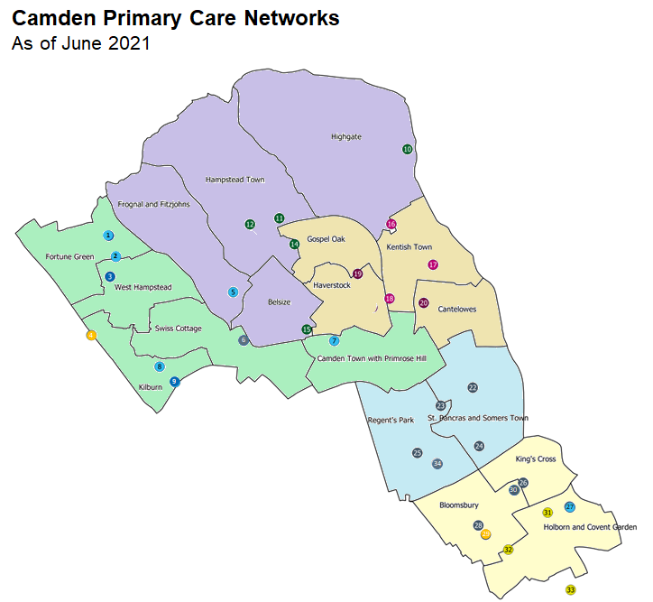
NW3
South
NW5
Central
West

