PATIENT FEEDBACK FORM
Tell us about your Annual Health Check. Put in a box

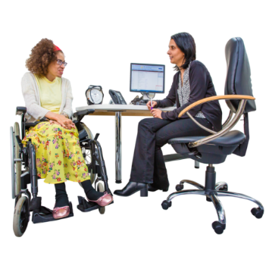
Are you happy about how your Annual Health Check was done?
Did we talk to you in a way that you understood?
Did we explain what will happen during your Annual Health Check?
Who did your Annual Health Check? | A nurse  Health Care Assistant  Doctor  Other
Was the person doing your Annual Health Check friendly?
Were you given a copy of the Health Check Action Plan?
Can you tell us what was good about your health check?
Can you tell us what was not good about your health check?

