Date of Communication: 18th September 2023 |  | Communication Ref No: EXT-COM-024/2023
Site: Barnet & Chase Farm RRL/ Royal Free RRL |  | Sent by: Angus Wyatt (Rapid Response Laboratory manager)
Communication title: Discontinuation of Shared Blood samples
COMMUNICATION DETAILS
GUIDANCE ON SENDING SAMPLES TO THE LABS

Requestors are encouraged to follow ONE LABEL = ONE SAMPLE good practice which is designed to ensure specimens are directed to the appropriate laboratory discipline as quickly as possible. This will reduce the incidence of delayed sample processing or lost specimens within the labs due to the requirement to transfer specimens between different pathology departments e.g. requests for FBC and HbA1c which are analysed in different laboratories should always be submitted using SEPARATE blood tubes. (In the below example, you will see that tQuest has been setup to ensure requests are grouped into different disciplines so that two distinct request forms and labels are generated for each request.)

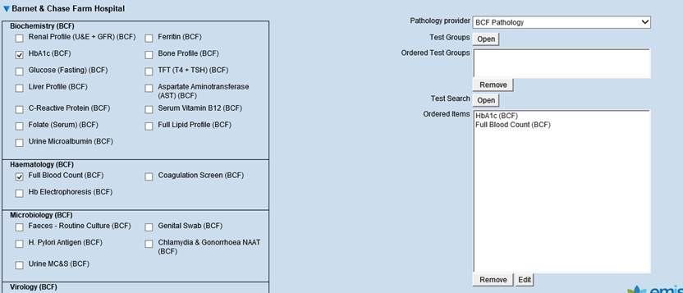

In efforts to ensure the laboratories are consistently able to provide results for all investigations requested we have taken the decision to discontinue the practice of sharing samples between different disciplines. Accordingly, from 1st February 2023 HSL implemented a stricter sample acceptance criteria whereby it was no longer possible to accept a single sample where two specimens are needed as specified in the tQuest test ordering catalogue. The test will be cancelled in line with standard operating procedure which has been agreed with respective clinical leads.

Accreditation Status | Accredited |  | UKAS Ref: |  |  | Awaiting accreditation |  | Not applicable
Action required by the client:  YES NO | Action Target date: |  |  |  | 31/01/2023
Details of the required action(s):  (where applicable) | Please cascade this information to all relevant staff and service users.
Required actions complete and closed by: | Name: |  |  | Sign: |  |  | Date:
Evidence of actions received and attached where applicable | Name: |  |  | Sign: |  |  | Date:

