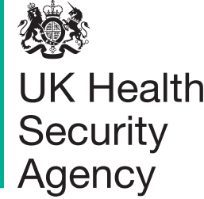

Measles
Communications toolkit for UKHSA stakeholders
Version 2

The UK Health Security Agency (UKHSA) is working with partners in the NHS, local authorities and national government to protect people from measles, including the most vulnerable amongst us.
This toolkit aims to support stakeholders with messages to help protect people from measles. It contains background information, social media assets and suggested copy, resources for health professionals, and other useful information.
The information provided is correct as of 31 January 2024.

Further information:
For further information about our national communications please contact: externalaffairs@ukhsa.gov.uk
For further information about our regional support please contact your UKHSA regional communications lead.
Sign up to our Stakeholder Cascade to receive a weekly newsletter with the latest news, updates and guidance from UKHSA
Follow UKHSA on X (Twitter): @UKHSA
Visit our website at GOV.UK

Contents

Further information: 1
Measles general information 2
Key messages on MMR vaccine 3
NHS advice 3
NHS national MMR catch-up campaign for children aged 6 to 11 years 3
MMR vaccine general information 4
The MMR vaccine ingredients 4
Measles communications assets for raising awareness amongst the public 5
Information for health professionals 6
National guidelines 8
Suggested post copy social media assets 8
Statistics 15
Template UKHSA regional statement 15
Template communications article for internal / external channels on MMR vaccine call 16

Measles general information

Measles spreads very easily among those who are unvaccinated.

Measles can be a very unpleasant illness. In some children it can be very serious and lead to hospitalisation – and in rare cases tragically can cause death. People in certain risk groups including babies and young children, pregnant women, and people with weakened immunity, are at increased risk of complications from measles.

Symptoms include a runny nose, cough, high fever, sore red watery eyes and a blotchy red-brown rash.

Having two doses of the Measles, Mumps, Rubella (MMR) vaccine at the right time (dose 1 from 12 months and dose 2 from 3 years 4 months) is the best way to protect your child and help prevent it spreading, especially to those most vulnerable. Two doses of the MMR vaccine give you excellent lifelong protection. If you or your child have missed out, contact your GP surgery to catch up as soon as possible.

There has been a recent, increase in measles cases in England, including (at the time of writing) an ongoing outbreak centred in Birmingham and around the West Midlands region of England. Most of the cases have been in children under the age of 10 years with many outbreaks linked to nurseries and schools.

Uptake of the routine childhood vaccinations, including the MMR vaccine is the lowest it has been in a decade and is well below the 95% uptake needed to protect the population and prevent outbreaks. This is giving this serious disease a chance to get a foothold in our communities. Achieving high vaccination coverage across the population is important as it also indirectly helps protect very young infants (under one) and other vulnerable groups.
UKHSA has declared a national incident to coordinate the investigation and response to the rise in measles cases and this is informing communication strategies across partner organisations, ensuring facts are communicated clearly alongside a call to action.
This communications toolkit is to support UKHSA and its partners with managing communications related to the rise in measles cases and signposts to the latest materials.

Key messages on MMR vaccine
- Measles spreads very easily among those who are unvaccinated, especially in nurseries and schools. It can be a very unpleasant illness and in some children can be serious and lead to hospitalisation and complications – and in rare cases tragically can cause death. Vaccines are our best line of defence against diseases like measles and help stop outbreaks occurring in the community.
- We are calling on all parents and guardians to make sure their children are up to date with their 2 MMR doses. To see if your child is up to date with their MMR vaccines, check your child’s personal child health record (PCHR), known as the red book, or contact your GP practice. People may also be able to check their vaccination status on the NHS App.
- It is never too late to catch up. The MMR vaccine is free on the NHS, whatever your age. If anyone has missed one or both doses of the MMR vaccine, contact your GP practice to book an appointment.

NHS advice
There is information on measles on the NHS website. This includes advice to parents and carers to check if their child has measles, including photos of the measles rash. The rash looks brown or red on white skin. It may be harder to see on brown and black skin.

Measles is a highly infectious viral illness, so anyone with symptoms is advised to stay at home and phone their GP or NHS 111 for advice, rather than visiting the surgery or A&E, to prevent the illness spreading further.

There is information available from the NHS on the MMR vaccine.

NHS national MMR catch-up campaign for children aged 6 to 11 years

On 22 January 2024, the NHS launched a catch up campaign for missed MMR vaccines.
The campaign will see all parents of children aged from six to 11 years contacted encouraging them to make an appointment with their child’s GP practice for their missed MMR vaccine.
It will target areas with low uptake of the vaccine with the health service contacting just over one million people aged 11 to 25 years-old in London and the West Midlands to invite them to catch up on their missed MMR vaccinations.
For more information about the campaign, please visit the nhs.uk website.

MMR vaccine general information

Vaccines are our best line of defence against diseases like measles and help stop outbreaks occurring in the community.

Children are offered the first dose of the MMR vaccine when they turn one and the second dose when they are about 3 years 4 months old, before they start school.

In recent years, uptake of the routine childhood vaccinations, including the MMR vaccine has fallen. Uptake for the first dose of the MMR vaccine – which protects against measles, mumps and rubella – in children aged 2 years in England is 89% and uptake of 2 MMR doses in children aged 5 years is 85%. This is well below the 95% target set by the World Health Organization (WHO), which is necessary to achieve and maintain elimination.

We are calling on all parents and guardians to make sure their children are up to date with their 2 MMR doses. It’s never too late to catch up, and you can get the MMR vaccine for free on the NHS whatever your age.

The MMR vaccine ingredients

Evidence suggests there is confidence in NHS vaccination programmes and parents largely trust the advice that they get from practice nurses, general practitioners, pharmacists and from the NHS. For example, UKHSA’s annual survey of attitudes to vaccines among parents shows high confidence in the childhood & adolescent NHS vaccine programmes, which shows confidence has actually improved over the period when coverage was declining. In addition, the same survey showed almost 90% of parents understand the benefits of vaccination for their children and trust the NHS England immunisation programmes.

However, we understand the issue of pork ingredients (known as ‘porcine gelatine’) in some vaccines has raised concerns among some groups.

There is limited awareness amongst some groups that there is an MMR vaccine available that does not contain pork products (known as ‘porcine gelatine’). It would be beneficial, particularly for healthcare professionals and community leaders, to consider providing this information more clearly in discussions about the MMR vaccine where there are concerns (for example on religious or ethical grounds) that may lead to reduced uptake.

For background, UKHSA and NHS England has a leaflet which explains how and why porcine gelatine is used in vaccines, and the alternatives available. There is also information available on the NHS website on why vaccination is important.

Suggested messages on MMR vaccine ingredients:

- In the UK we have two types of MMR vaccine – MMR VaxPro® and Priorix®. Priorix® does not contain any pork ingredients and is as safe and effective as MMR VaxPro®. For both vaccines, a full two doses will provide protection against measles, mumps and rubella.

- You can request Priorix® from your GP. Parents can also make this request for children. Please note some GP practices may need to order this product in specially so it will be helpful to tell them your views before the appointment.

Measles communications assets for raising awareness amongst the public

There is further information below which you may wish to use on your own channels:
- We have created a variety of social media assets that encourage people to check they and their children are up to date on their MMR vaccines.
- A video from Dr. Colin Campbell, Consultant Epidemiologist at UKHSA, who explains how infectious the measles virus is and information on the vaccine.
- We also have a blog on immunisations in which Vanessa Saliba, UKHSA's Consultant Epidemiologist for Immunisations, outlines the importance of protecting children through vaccination.
- Other publications and assets on MMR can be downloaded and ordered for free by healthcare professionals on the health publications website.
- UKHSA resources on immunisation can be found on our website.
- We also have a blog on immunisations in which Vanessa Saliba, UKHSA's Consultant Epidemiologist for Immunisations, outlines the importance of protecting children through vaccination.
Example assets below:

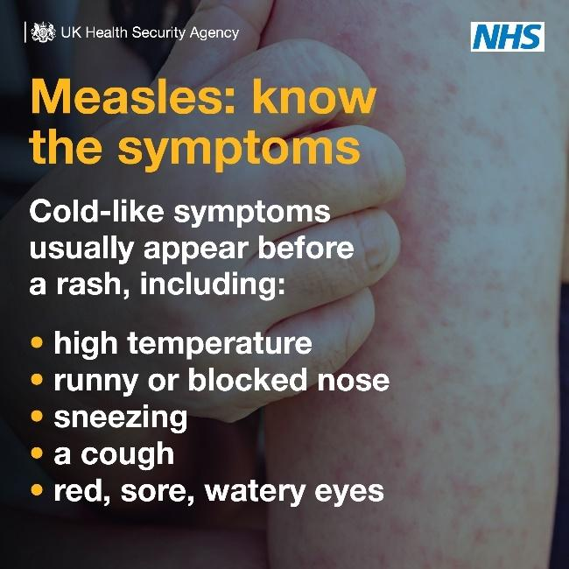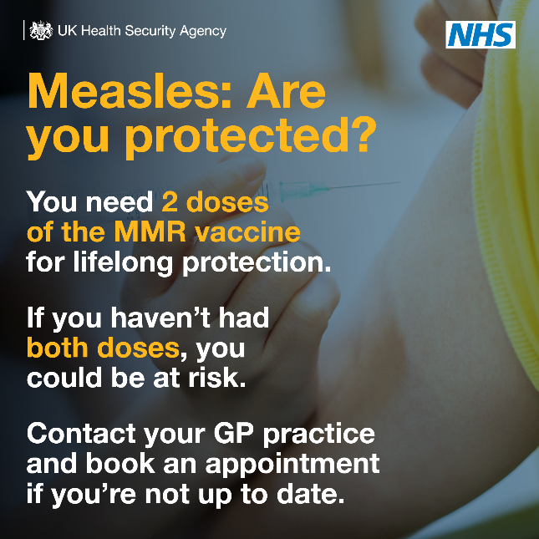

Information for health professionals

- Following a UKHSA risk assessment published July last year, a joint letter from UKHSA and NHS England was sent to health professionals and Directors of Public Health in England to remind colleagues of the risk of a measles outbreak in London due to the sub-optimal uptake of the MMR vaccine in the capital and in some other communities around the country. The letter notes that outside of London, there is high risk of cases linked to overseas travel in specific population groups.
- UKHSA has produced a new poster for health professionals to help them identify measles, what to do if they suspect measles and ensuring staff are fully vaccinated. Health professionals can download and order the poster for free via the health publications website.
- Training slide sets for health professionals:
  - Measles: an update for maternity services.
  - Measles: an update for paediatrics and A&E.
  - Measles: an update for primary care.
  - Measles, mumps and rubella (MMR) vaccination programme for immunisers.
- Other publications and assets on MMR for can be downloaded and ordered for free by healthcare professionals on the Health Publications website. Many of these resources are available in translated community languages including: Afrikaans, Albanian, Arabic, Bengali, Brazilian Portuguese, Bulgarian, Cantonese, Chinese (simplified), Chinese (traditional), Estonian, Farsi, Greek, Gujarati, Hindi, Italian, Latvian, Lithuanian, Panjabi, Pashto, Polish, Portuguese, Romanian, Romany, Russian, Somali, Spanish, Tagalog, Turkish, Twi, Ukrainian, Urdu, Yiddish and Yoruba.
- UKHSA resources on immunisation can be found on our website.

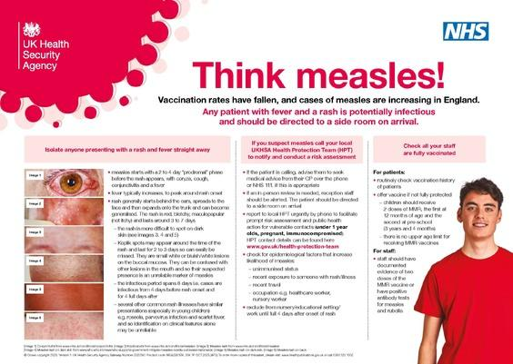

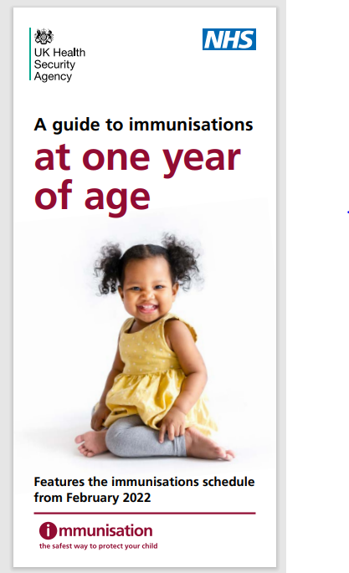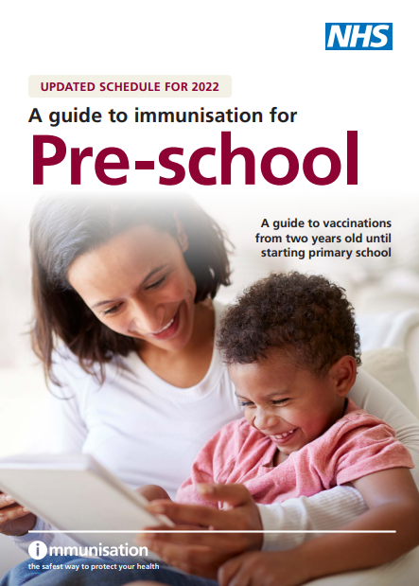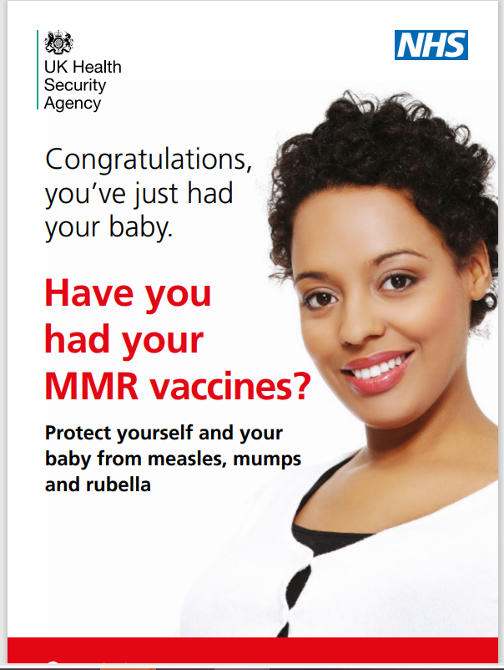

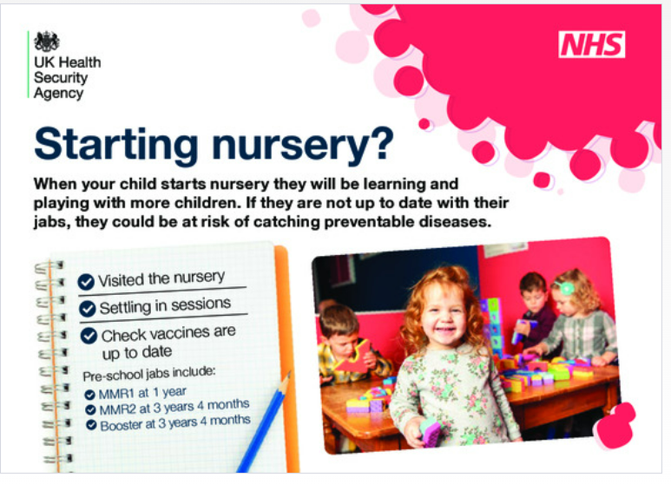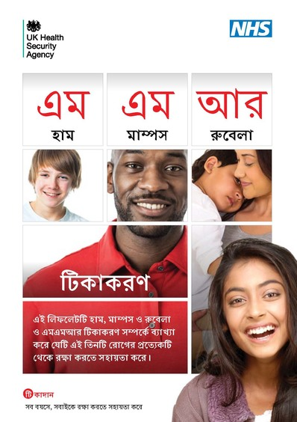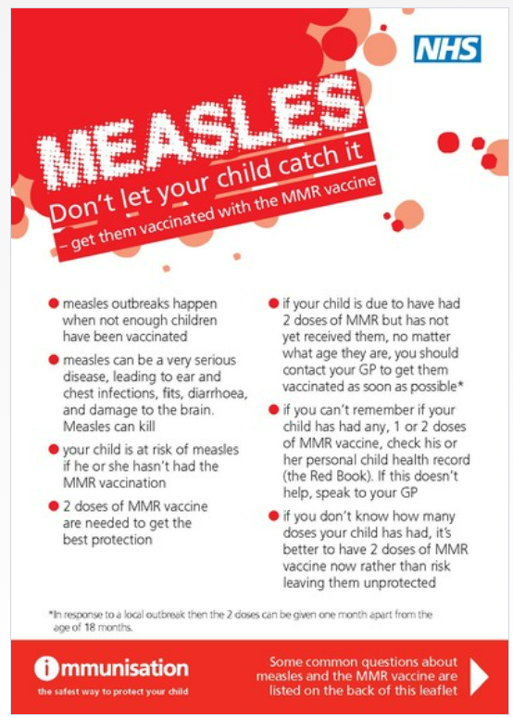

National guidelines

UKHSA has published national measles guidelines. This guidance is for health professionals on how to deal with cases of suspected measles: what patient details to take, who to notify and assessing risk of disease spreading in close contacts.
This guidance for health professionals covers:
- how to decide if a suspected case of measles is ‘likely’ or ‘unlikely’
- what patient details to take
- who to notify
- assessing risk of disease spreading in close contacts
- case management – what lab tests should be done and the importance of oral fluid testing on all suspected cases
- measles control – identifying vulnerable contacts and assessing their need for post-exposure prophylaxis

Suggested post copy social media assets

Measles
Suggested post copy | Graphic | Alt text
Measles spreads easily.  Anyone who is not vaccinated can catch it.  Measles can cause serious complications and can be fatal, so make sure you’re up to date with #MMR vaccinations and ask your GP practice about catch up jabs if needed. |  | GIF. Measles can cause serious complications and can be fatal. Is your child protected? Vaccinate to protect your child against measles, mumps and rubella. Two doses of MMR give protection for life. Make sure your child is up to date: At 1 year. At 3 years 4 months. Contact your GP if your child has missed any vaccinations. Adults who missed out on the MMR in childhood can catch up at any time. Visit nhs.uk/MMR for more information.
Measles can cause serious complications and can be fatal  But 2 doses of the #MMR vaccine can offer protection for life. Make sure you & your loved ones are up to date with their jabs, and if not, contact your GP practice for a catch-up appointment. |  | GIF. Measles can cause serious complications and can be fatal. . Is your child protected? Vaccinate to protect your child against measles, mumps and rubella. Two doses of MMR give protection for life. Make sure your child is up to date: At 1 year. At 3 years 4 months. Contact your GP if your child has missed any vaccinations. Adults who missed out on the MMR in childhood can catch up at any time. Visit nhs.uk/MMR for more information.
If you’re planning to travel abroad during the school holidays, make sure to check your child is up to date with their vaccinations, including the #MMR vaccine. Contact your GP practice to book any catch up jabs before you travel ✈🚢🚉 | 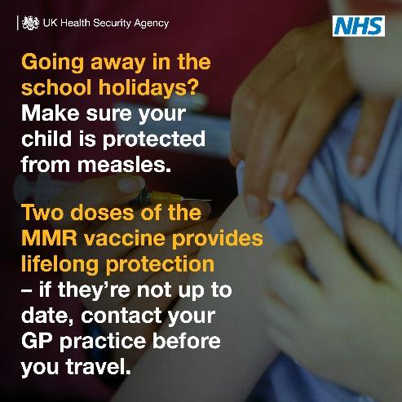 | Going away in the school holidays? Make sure your child is protected from measles. Two doses of the MMR vaccine provides lifelong protection – if they’re not up to date, contact your GP practice before you travel.
Measles can have serious and sometimes fatal consequences and is still common in many countries worldwide. Before you travel, make sure you & your loved ones are up to date with #MMR vaccinations. | 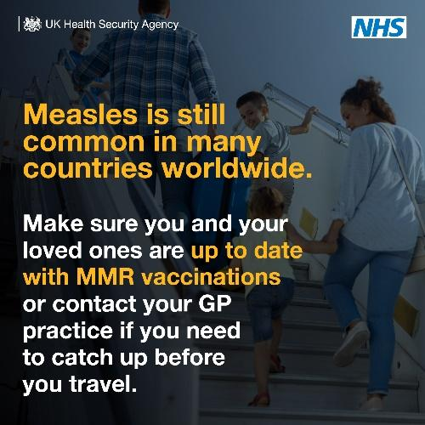 | Measles is still common in many countries worldwide. Make sure you and your loved ones are up to date with #MMR vaccinations or contact your GP practice if you need to catch up before you travel.
Getting lifelong protection against #measles is simple – you just need to have 2 doses of the #MMR vaccine. If you think you or a loved one isn’t up to date, contact your GP practice to book a catch up appointment. | 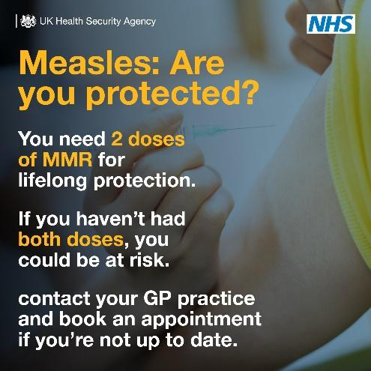 | Measles: Are you protected? You need 2 doses of MMR for lifelong protection. If you haven’t had both doses, you could be at risk. Contact your GP practice and book an appointment if you’re not up to date.
Here’s what you need to know about #measles, from the signs and symptoms to look for to what to do if you think you or your child has measles.  More info: https://www.nhs.uk/conditions/measles/ | 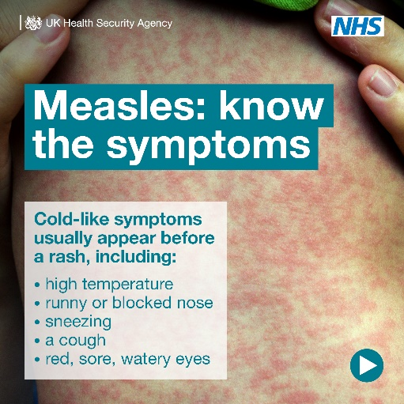 | GIF. Measles: know the symptoms  Cold-like symptoms usually appear before a rash, including: High temperature, Runny/blocked nose, Sneezing, A cough, Red, sore, watery eyes  The measles rash. A rash usually appears a few days after the cold-like symptoms. The spots are sometimes raised and join together to form blotchy patches. They’re not usually itchy. The rash looks brown or red on white skin. It may be harder to see on brown and black skin. Spots in the mouth. Small white spots may appear inside the cheeks and on the back of the lips a few days later. These spots usually last a few days. Call ahead. If you think you or your child have measles, call your GP surgery or NHS 111 first, before turning up at a healthcare setting. This will help to stop the virus spreading.
*Please note: The following graphics are meant to be used as part of a carousel, and not as standalone graphics*
#Measles can be a serious infection that can lead to complications, especially in young children & those with weakened immune systems.  We’re reminding parents on what signs and symptoms to look out for and what to do if they think their child has measles.  Measles spreads easily but it is preventable. Make sure you & your loved ones are up to date with your #MMR jabs or catch up on any missed jabs.  More info: https://www.nhs.uk/conditions/measles/ |  | Measles: know the symptoms  Cold-like symptoms usually appear before a rash, including: High temperature, Runny or blocked nose, Sneezing, A cough, Red, sore, watery eyes
 | 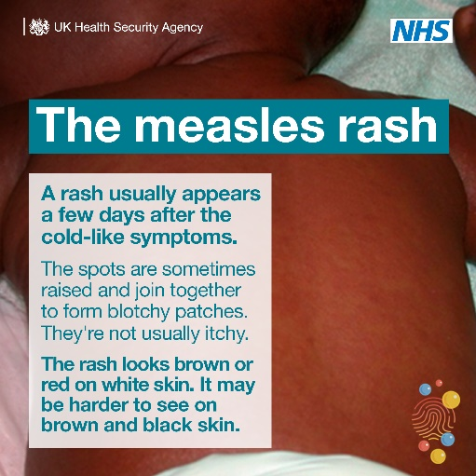 | The measles rash. A rash usually appears a few days after the cold-like symptoms. The spots are sometimes raised and join together to form blotchy patches. They’re not usually itchy. The rash looks brown or red on white skin. It may be harder to see on brown and black skin.
 | 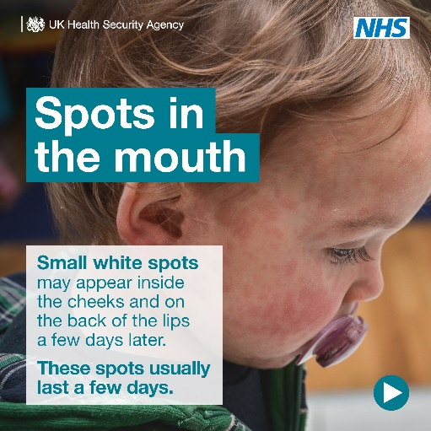 | Spots in the mouth. Small white spots may appear inside the cheeks and on the back of the lips a few days later. These spots usually last a few days.
 | 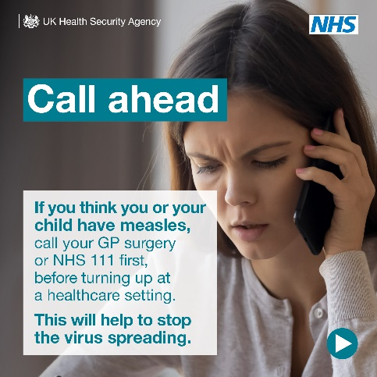 | Call ahead. If you think you or your child have measles, call your GP surgery or NHS 111 first, before turning up at a healthcare setting. This will help to stop the virus spreading.

Statistics

UKHSA and health partners publish various data and commentary:
- The latest number of laboratory confirmed measles cases in England by month, age and region have been published by the UKHSA in an updated epidemiological overview. Updates will be published every Thursday going forward.
- UKHSA publishes quarterly data and commentary on uptake/coverage achieved by the UK childhood immunisation programme: Cover of vaccination evaluated rapidly (COVER) programme 2023 to 2024: quarterly data. At the time of writing, this was last published on 19 December 2023 covering the period July to September 2023.
- A statistical report, co-authored by NHS England and UKSHA, reports childhood vaccination coverage statistics for England in 2022-23. This includes a childhood vaccination coverage dashboard, presented as a timeseries, at local authority, region and England level.

Template UKHSA regional statement
Specialists from the UK Health Security Agency (UKHSA) are working with NHS and local authority partners following xx confirmed cases of measles in a (LA) school.
To help reduce the risk of further measles cases UKHSA is advising everyone to be alert to signs and symptoms and urge people to check their families are fully vaccinated against measles.
Measles is extremely infectious and sadly in some instances can have very serious, causing long term and life changing consequences. The best protection against measles is the MMR vaccination.
It is important that anyone who hasn’t already had two doses of the MMR vaccine contacts their GP surgery for an appointment to get vaccinated.
The symptoms of measles can include cold-like symptoms, sore red eyes, a high temperature and a red-brown blotchy rash. If you experience these symptoms seek medical attention but be sure to phone ahead before you visit your GP surgery or other healthcare setting, so arrangements can be made to prevent others from being infected.
Notes to Editors
For further information about measles, please visit https://www.nhs.uk/conditions/measles/
Information about the MMR vaccine can be found by visiting https://www.nhs.uk/conditions/vaccinations/mmr-vaccine/

Local Authority media handling
Any media queries relating to measles or MMR please liaise closely with your UKHSA regional contact.

NHS media handling
NHS colleagues please liaise with your NHSE regional team.

Template communications article for internal / external channels on MMR vaccine call

Measles cases prompt MMR vaccine call

UKHSA has reported an increase in measles across the country and is encouraging people to check that they and their children have had two doses of the MMR vaccine.

The free MMR vaccine is a safe and effective way of protecting against measles, as well as mumps and rubella.

It’s important for parents to take up the offer of MMR vaccination for their children when offered at 1 year of age and as a pre-school booster at three years, four months of age. If children and young adults have missed these vaccinations in the past, it’s important to take up the vaccine now from GPs, particularly in light of the recent cases.

Check your child’s Red Book to see if they’ve received MMR vaccinations as scheduled or check with your GP surgery if you’re unsure. Most healthy adults will have developed some immunity to measles but can still receive two doses of the vaccine from their GP too.

Anyone with symptoms is also being advised to stay at home and phone their GP or NHS 111 for advice.

Measles symptoms to be aware of include:
- high fever
- sore, red, watery eyes
- coughing
- aching and feeling generally unwell
- a blotchy red brown rash, which usually appears after the initial symptoms.

For more information about measles, see the nhs.uk website.

