ACTIONS FROM MY HEALTH CHECK (Copy to be given to patient).
YOUR NAME: DATE:
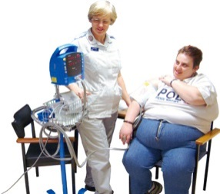 | Done by:
 | My Height:
 | My Weight:
 | My Blood Pressure:
 | Date for next Check:
 | Do I need to see my doctor? When and why (a blood test?):
 | Do I need to see anyone else? (Who and Why):
 | Health actions: (what, who and when)
 | Anything else I need to know?

