West Herts Community Paediatric Service
Children & Young Person’s Specialist Admin Hub

Telephone:
01923 470 680 (Press Option 2, then Option 1)

Email: HCT.CYPSpecialistServices@nhs.net

Dear Parent or Guardian

Your child is on the waiting list for an initial assessment with the Community Paediatric Service at Hertfordshire Community NHS Trust (HCT).

We acknowledge we have long waiting times and HCT is working closely with commissioners (who fund the service) and the team to review the service and find solutions to address the waiting times and provide support to children and young people as soon as possible.

Please rest assured, your child will remain on our waiting list and will be allocated an appointment as soon as we are able to. The service will, where available, employ temporary consultants and doctors to undertake assessments, so that your child can be seen sooner.

In case of emergency or in a crisis, if you do not feel that you are able to keep your child or family safe, please contact your GP, the emergency services via Accident and Emergency or by calling 999. If your child is under 5, you can also contact your Health Visitor for support and guidance.

Additional information on sources of support for you, your child, and your family while you are awaiting an appointment can be found on our website. Please visit: www.hct.nhs.uk/our-services/childrens-community-medical-team (and scroll down to the ‘Useful Information’ tab).

If you feel your child no longer needs an assessment, please contact our Admin team 01923 470 680 (press Option 2, then Option 1) and they will remove your child from the waiting list.

Thank you in advance for your patience and understanding while we work to reduce our waiting lists. As soon as we have allocated an appointment to your child we will be in contact again.

We understand that living in a family where someone has additional needs or is seeking a diagnosis can be challenging. It's natural for this to have an impact on the mental health of both parents and children. If you feel like you or your child might need mental health support, we encourage you to reach out. You can call the NHS Single Point of Access (SPA) on 0800 6444 101 to make a mental health referral for you or your child. This number is for anyone in Hertfordshire who would like a referral for mental health treatment. Additionally, if you would like more support with issues relating to autism or ADHD, please call ADD-vance on 01727 833963 (Mon – Fri, 9am – 1pm).

Please see attached links to other organisations that you may find useful.

Yours sincerely

Charles Cadogan
Operations Lead Specialist Services: Children and Young People

Your feedback is welcome and can be made through this QR link:
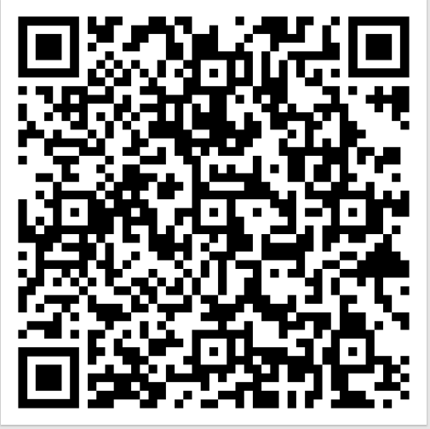

Further Support:
Bowel & Bladder (potty training): ERIC www.eric.org.uk
Sleep package: www.thesleepcharity.org.uk/information-support/children/
OT website: https://www.hct.nhs.uk/our-services/childrens-occupational-therapy
DSPL Leaflet: Support in the local area can also be accessed through the ‘Delivering Special Provision Locally’ (DSPL) partnership. DSPL provides a range of support across the county for children and young people with special educational needs and disabilities. Further information about DSPL can be accessed at the following address
https://www.hertfordshire.gov.uk/microsites/local-offer/education/dspl/delivering-special-provision-locally.aspx
For Dacorum specifically:
http://www.dacorumdspl.org.uk/#
For St Albans and Hertfordshire
http://dspl7.org.uk/#
For Watford
http://dsplarea9.org.uk/#

Parenting Courses
http://www.dacorumdspl.org.uk/courses-for-parents-carers-and-professionals/
SENDIAS Leaflet
www.herts.sendiass.org.uk
www.familylives.org.uk - Family Lives is a national charity providing help and support in all aspects of family life, including parenting courses.

Autistic Spectrum Disorder:
www.autism.org.uk/parents National Autistic Society website includes information about autism and Asperger syndrome, the NAS and its services and activities.
www.spaceherts.org.uk/index.htm Space is a Hertfordshire based charity supporting parent/carers of children and young people on the Autistic Spectrum, with Attention Deficit Hyperactivity Disorder (ADHD) or a related condition.
https://angelssupportgroup.org.uk - Hertfordshire charity supporting families of children with Autistic Spectrum Condition and/or ADHD.
www.nasbranch.org.uk/Hertfordshire - the Hertfordshire branch of the National Autistic Society. Email hertfordshire@nas.org.uk
www.hopeforautism.org - A local support group for families who have a child with autism.
www.familiesinfocus.co.uk - offer free autism parenting courses https://www.hertsfamilycentres.org/family-centres.aspx Information about Hertfordshire family centres (offer parenting courses etc.)

Special Educational Needs and Disabilities:
www.kids.org.uk/hub - The KIDS East and West HUB services offer information and support for parents and carers of disabled children/children with additional needs aged 0-19 in Hertfordshire.
https://www.hertfordshire.gov.uk/microsites/local-offer/the-hertfordshire-localoffer.aspx Information about the local offer - services for children and young people with Special Educational Needs in Hertfordshire
https://www.hertfordshire.gov.uk/microsites/local-offer/support/sendiass.aspx - Special Educational Needs and Disability Information Advice and Support Service (SENDIASS) impartial information, advice and support service funded by Hertfordshire County Council for parents, carers, young people (0-25) and professionals.
https://www.hertfordshire.gov.uk/microsites/local-offer/tell-us/hertfordshire-additionalneeds-database.aspx - Information on Hertfordshire Additional Needs Database (HAND), with an online newsletter, Information on benefits, activities, support groups https://www.thegrid.org.uk/learning/sen/whole_school/dspl/news/documents/herts_a utism_report_exec_summary.pdf - Review of educational provision in Hertfordshire for children and young people on the autism spectrum 2015
www.mencap.org.uk - Support group and services for learning disabled children and their families.
www.minded.org.uk – free educational resource on children and young people’s mental health.

More information on supporting sensory challenges in the classroom can be found at http://network.autism.org.uk/knowledge/insight-opinion - ‘Sensory challenges for autistic pupils

