INVITATION LETTER for your Annual Health Check
Date: Please amend this letter.
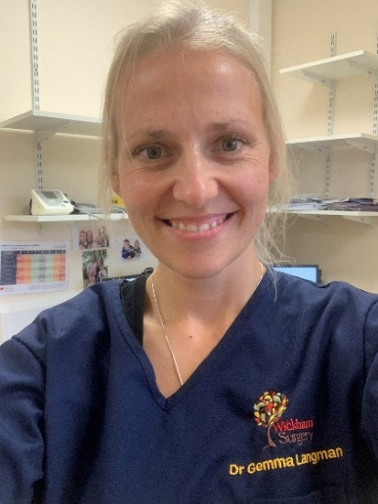 | Hello ………, my name is Dr Gemma Langman.  I am a doctor at your doctor’s surgery.  This is my photo.
Because of the Coronavirus, everyone at the surgery has to wear:

- a face mask
- apron
- goggles
- gloves

This is called Personal Protective Equipment or PPE.

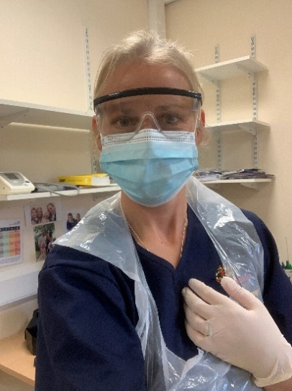 | When wearing PPE, people look different.  I want to show you what I look like with my PPE on.  But this is still me!
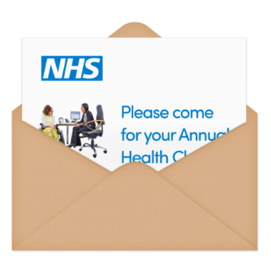 | I want to invite you for your Annual Health Check.
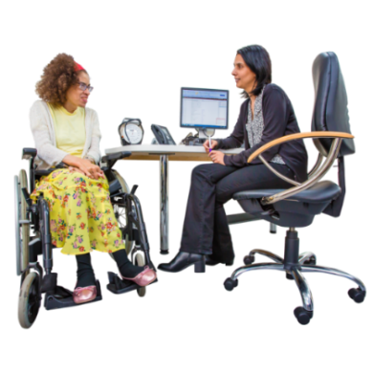 | Annual Health Check is important.  I will ask you questions about your health.  We can talk about how to stay healthy or what help you need.
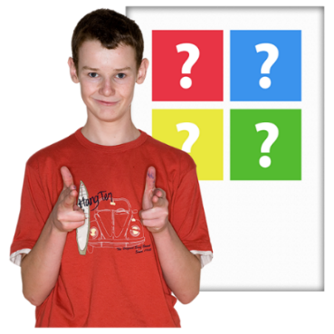 | You can have a blood test and flu jab too.  Having a blood test and flu jab is your choice!  So please do not worry.
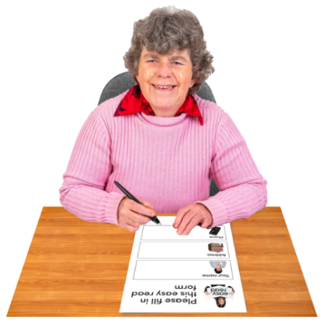 | If you want to, you can complete the Easy Read form I have sent to you.  (Or you can download it from: Health Information including annual health check, epilepsy, dental advice, health action plans (southernhealth.nhs.uk))  Look under the Annual Health Check section; you need form 1C or 1D.  If you complete this form, you can either:  Sent it back to me OR Bring it with you to your appointment.  If you need help with the form, ask someone you trust.  But you can still come to your appointment without the form!

I need to know what kind of appointment you would like.

Please choose 1 option.

Telephone  Appointment | Video  Appointment  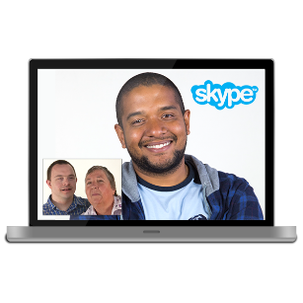 | Appointment at the surgery  (we call this face to face)
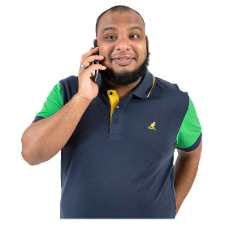 | Can you please call the surgery to tell us what kind of appointment you would like?  (If you need to have your health check at home, talk to your surgery.)  The number you need to call is:  ……………………………………..  THANK YOU.

