Member Self-Service – view your pension benefits online
Online access to financial systems is expected in today’s society, and your pension administrators, XPS, are now in a position to provide this function for you, enabling you to view your pension benefits online.
The system is available to all active scheme members using a system known as Member Self-Service (MSS) which allows you to log into your pensions record online.
This secure website allows you to use a number of benefit projectors* and to view your annual benefit statement online.
To access the site, all you need to do is visit:
https://www.myownpension.org.uk/altairMSSWeb/login?cid=25
We have supplied XPS with your current active work email address and this will have been added to your pension administration record. This means you will be able to simply click on ‘sign up’ and complete the information as necessary. Instructions are included below.
Please note: You must sign up with your current active work email for the process to work correctly. The email addresses supplied to XPS are in the format joe.bloggs.1234@derbyshire.pnn.police.uk
If you have any questions regarding registration, please do not hesitate to get in touch with XPS by calling 01642 727222 or email MSS@XPSGroup.com. Alternatively, you can write to XPS Administration, P. O. Box 485, Middlesbrough, TS1 9EE.

*The benefit projector calculator is accurate in the vast majority of cases and will show you the approximate value of your pension benefits when you retire. However, your personal circumstances may change between now and when you retire which means that your pension benefits will change as well.
Therefore, it is very important that you realise that this calculator can only give you an approximation of what your pension is likely to be when you retire.
Also, in certain circumstances, rules apply that are beyond the scope of this calculator (please read the warnings section on member self-serve).
You should not make any decisions about when or why you retire based on the results from this calculator.
Work is continuing on this calculator to ensure that in time it will be able to calculate accurate estimates for all scheme members.
To complete the registration process please follow the below instructions.

PLEASE NOTE: This service is NOT compatible with the default browser in Windows 10 called EDGE.

If your computer is running Windows 10, click on the START button > All Apps and then look under Windows Accessories. You should find it listed there.
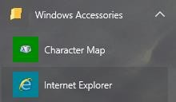

Or in the search box type INTERNET EXPLORER.

- Please click the following web link:
https://www.myownpension.org.uk/altairMSSWeb/login?cid=22
- We recommend you add this page to your Internet Browser ‘Favourites’ to make it easier to login again in the future
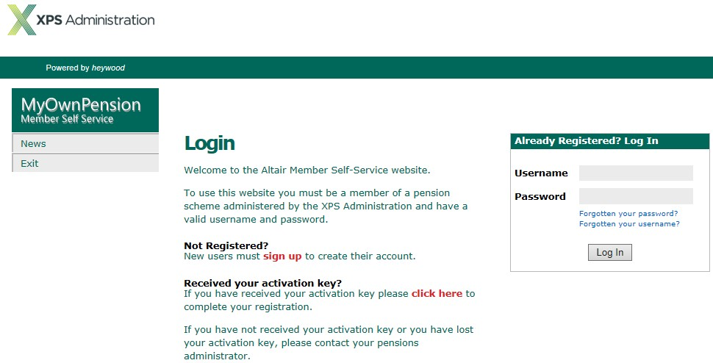
- Click “Sign Up”.

- Please complete the below boxes, then click SUBMIT.

Surname
  - National Insurance Number
  - Date of birth
  - Email address – The email address you are using throughout this process.
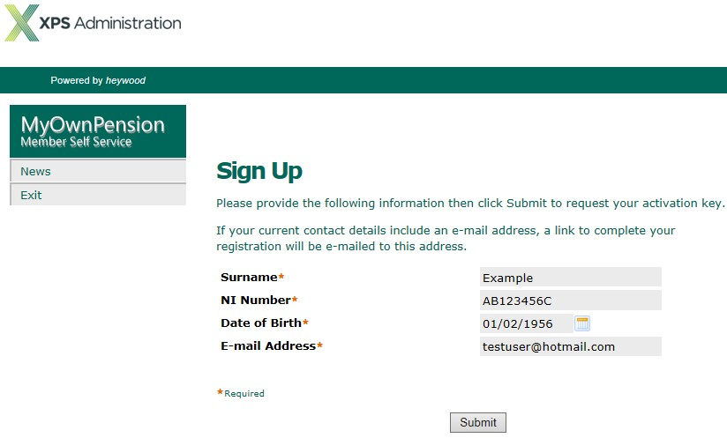

- You will then receive an email which contains the activation link you need to complete the final registration process (as shown below).
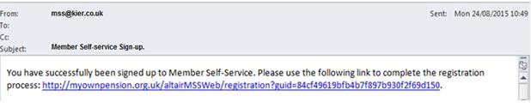

- Click this link and you will be taken to a screen where you are required to now create:

Username
  - Password
  - 2 x Security Questions

When finished, click the REGISTER button
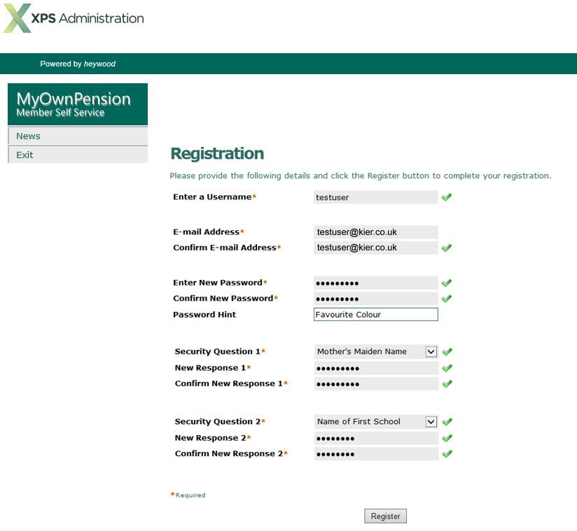

New password should be between 8 and 12 characters in length and must include at least one numeric, one lower, one upper case and one special character.
(For example $£^#/.@*) (Passwords are case sensitive)

You should now have been returned to the Login Page (as shown below)
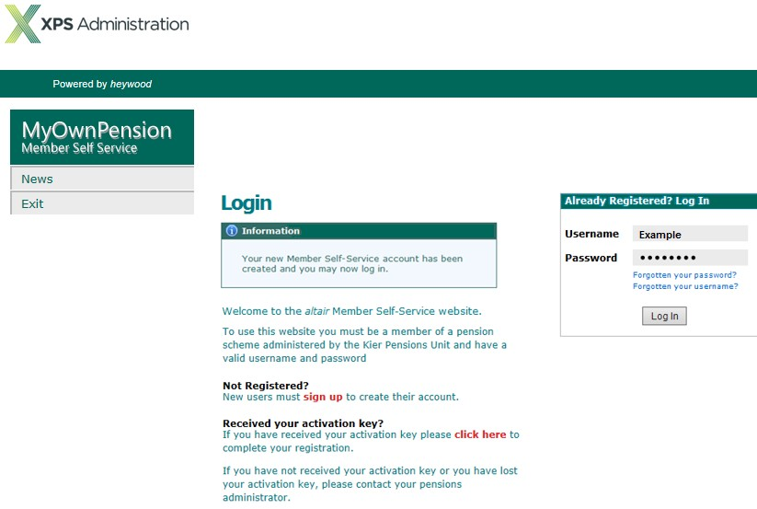

- Finally, enter your newly created:

Username
  - Password.

Into the required boxes and click LOG IN.

You will then be asked one of the two security questions you set up as part of the registration process. Enter your security response and click CONTINUE.
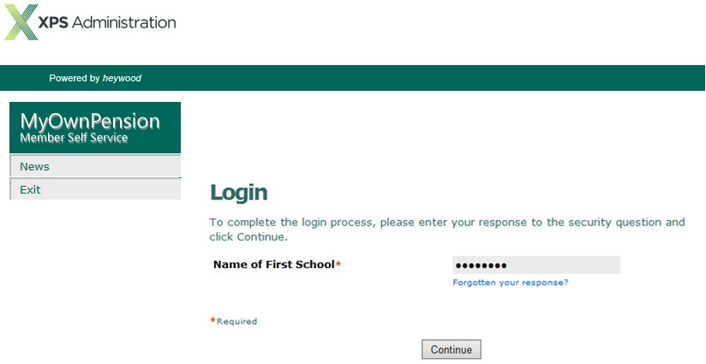

- You will now be logged in to your pension details online!

If you have any difficulties completing the registration process or have any questions once you are logged in, please contact XPS Administration by telephone on 01642 727222 or you can send us and email by clicking here .

